Project Design Phase-II

Data Flow Diagram & User Stories

|  |  |
| --- | --- |
| Date | 03 October 2022 |
| Team ID | NM2023TMID08418 |
| Project Name | Analytics Tool For Placements |
| Maximum Marks | 4 Marks |

# Data Flow Diagrams:

A Data Flow Diagram (DFD) is a traditional visual representation of the information flows within a system. A neat and clear DFD can depict the right amount of the system requirement graphically. It shows how data enters and leaves the system, what changes the information, and where data is stored.

A Data Flow Diagram (DFD) for an Analytics Tool for Placements would represent the flow of data within the system. In a simplified description, you would typically have:

1. **Processes:**
   * Data Collection: This process collects data from various sources, such as student records, job listings, and placement outcomes.
   * Data Processing: Data is processed to clean, transform, and aggregate it for analysis.
   * Data Analysis: Analytics tools process the data to derive insights and trends.
   * Data Visualization: Data is presented in a user-friendly format through dashboards and reports.
2. **Data Stores:**
   * Student Data Store: Contains student profiles and relevant information.
   * Job Listings Data Store: Stores information about available job listings.
   * Placement Data Store: Stores placement outcomes and statistics.
   * Processed Data Store: Temporarily holds data during processing.
   * Analytics Results Store: Stores the results of data analysis.
3. **Data Flows:**
   * Data flows between processes, representing the movement of data from data collection to visualization.
   * Data may also flow from the Data Stores to the Data Processing and Analysis processes

# Example: [(Simplified)](https://developer.ibm.com/patterns/visualize-unstructured-text/)

# 

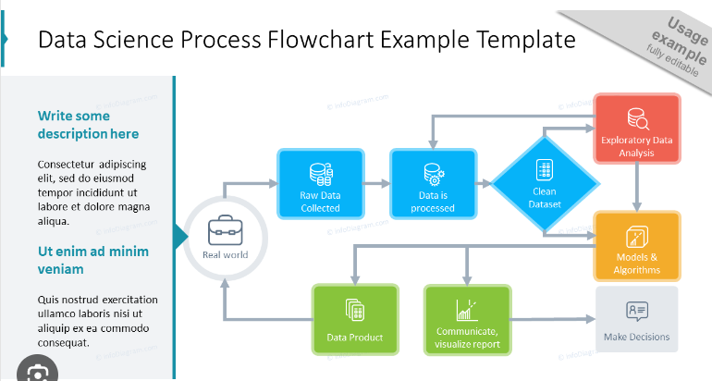

**User Stories:**

Use the below template to list all the user stories for the product.

|  |  |  |  |  |  |  |
| --- | --- | --- | --- | --- | --- | --- |
| **User Type** | **Functional**  **Requirement (Epic)** | **User Story Number** | **User Story / Task** | **Acceptance criteria** | **Priority** | **Release** |
| Customer (Mobile user) | Registration | USN-1 | As a user, I can register for the application by entering my email, password, and confirming my password. | I can access my account / dashboard | High | Sprint-1 |
| Administrator | User Management | USN-2 | Admins have full access to all data and functionalities. They can configure the system, manage user accounts, and oversee data collection and processing. | I can receive confirmation email & click confirm | High | Sprint-1 |
| Placement Coordinators | Placement Data Access | USN-3 | Placement coordinators need access to placement data and analytics. They should be able to view, update, and report on placement outcomes and trends | I can register & access the dashboard with Facebook Login | Low | Sprint-2 |
| Faculty and Staff | Student Progress Tracking | USN-4 | Faculty and staff members may require access to student and program-specific data. They can use the tool to track student progress and provide support. | The administrator can add new users, specifying their roles and permissions.. | Medium | Sprint-1 |
| Students | Profile Management | USN-5 | Students may access their own placement data and progress reports. They can contribute data to the system, such as updating their profiles and indicating job preferences. | Global preferences set by the administrator apply to all users. | High | Sprint-1 |
| Employers | Job Listing Management | USN-6 | Employers can input job listings and potentially access placement outcomes relevant to their organization. | The administrator can import student records in bulk from a CSV file, and the imported data is validated for accuracy. | Low | Sprint -1 |
| External Auditors and Regulatory Bodies | Read-Only Access | USN-7 | External auditors and regulatory bodies may need limited, read-only access to specific placement data for compliance and reporting purposes. | Data export options include downloadable reports in common formats like PDF or Excel. | High | Sprint-2 |
| Data Engineers and Analysts | Raw Data Access | USN-8 | Data engineers and analysts have access to raw data for data processing, analysis, and reporting. They play a crucial role in maintaining data integrity and generating insights. | Placement coordinators can view student profiles and update relevant information. | Medium | Sprint -3 |
| Data Integration Services | Data Ingestion and Synchronization | USN-9 | Data integration services may include APIs and data connectors that allow external systems to exchange data with the analytics tool. This involves data ingestion and synchronization. | Reports provide insights into placement outcomes for their area of responsibility. | Low | Sprint - 2 |